**PROJECT REPORT**

*Database Management System (CSL-220)*



**Hotel Management System**



*Group Members*

|  |  |
| --- | --- |
| **Name** | **Enrollment** |
| 1. Syed Shaheer Hassan | 02-134201-068 |
| 1. Kamal Kumar | 02-134201-058 |
| 1. Muhammad Hammad Ahmed | 02-134201-063 |

**Submitted to:**

**Engr.Ambreen Akram**

**BAHRIA UNIVERSITY KARACHI CAMPUS**

*Department of Computer Science*

***Module wise Work/Task Distribution***

|  |  |  |
| --- | --- | --- |
| **Name** | **Enrollment** | **Task** |
| 1. Kamal Kumar | 02-134201-058 | System and database designer |
| 2. Syed Shaheer Hassan | 02-134201-068 | System and database designer |
| 3. Muhammad Hammad Ahmed | 02-134201-063 | Database designer and documentation in charge |

***Abstract:***

This project **“Hotel Management System paper”** is made to facilitate the hotels that are using manual ways to keep their records for booking rooms, employee data, customer data and much more. This is an all in one program which manage multiple operations with efficiently and without any error and it does not even allow any human to make error while inserting in the data. This system will keep the record of past customers and their bookings, all the current bookings, current employees working and all the employees who have left the hotel plus the profit and loss will also be calculated for get a better understanding that how the business is doing. These all action will be performed efficiently and securely as it can’t be accessed without password and even with an id and password the receptionist won’t be able to access all the operations which admin can.

This project is made in **JAVA** and compiled in **Netbeans** version **8.2** an SQL database is connected for all the storing and managing of data through tables which will help in executing all the data anomalies. It is a GUI based project because without that the program wouldn’t be user friendly and the purpose of making this project would’ve be gone.

**TABLE OF CONTENT**

**CHAPTER 1**

1. INTRODUCTION
   1. *Project Description*
   2. *Scope of the Project*
   3. *Modules in Project*
   4. *Project Features*

**CHAPTER 2**

1. REQUIREMENTS SPECIFICATION
   1. *Hardware Requirements*
   2. *Software Requirements*

**CHAPTER 3**

1. ANALYSIS
   1. *Existing System*
   2. *Proposed System*

**CHAPTER 4**

1. DESIGN
   1. *ERD*
   2. *Normalization*

**CHAPTER 5**

1. SYSTEM IMPLEMENTATION

*5.1 Introduction*

*5.2 Queries*

**CHAPTER 6**

1. SCREEN SHOTS OF DATABASE & SYSTEM

**INTRODUCTION**

***Project Description:***

The sole purpose of the project is to replace the manual data record by creating a fully automated system which will make it a lot easier to organize and track record of each and every room, every customer including the hotel’s profit and loss. The paper written records can be misplaced and there is a lot of chance of human error in it. This program will make things a lot easier and quicker than in manually managing things because it’s a user-friendly program. The program will first ask for login and password for security and only after the correct ID and password it will connect to the database where all the data is stored. Then a menu will open where you can select number of options like book room, customer details, room details, and check availability of rooms, future booking plus the menus for employees and admin will be different because everything won’t be accessed by the receptionist because of security reasons. The program will keep track on the check inns and check outs and when will a certain room be open for booking again. Because of this program, user can keep the Hotel well managed. Other than managing rooms and keep data of all the customers the program will also be able to calculate profit and loss of the hotel to give the clear situation to the hotel management but this profit and loss will be shown to admin only. Employee salary will also be kept in track with this program. The major favor of using this program is that it can be used in many different hotels.

***Scope of the Project:***

* This program will keep the user for making any human error
* This will keep the record of the profit and loss
* This program will keep the record of the all the past bookings and customers
* All the employee data will be saved which are currently working and which have left
* The booking will be done in efficient way without error
* A booking can be updated as someone would like to extend their stay
* All the room record will be kept updated like when the room will be available for booking
* New rooms can be added or the data of the old ones can be updated
* New employees can be added and the data of the old ones can be updated

***Modules in Project:***

**Admin Module:** Admin has the access for all options in the program.

**Receptionist Module:** Receptionist has the access for only booking, update booking, search room availability, search the booking and keep an eye on check inns and check outs.

**Employee Module:** Employees can be added and their properties can be updated and viewed who are currently working and who have left the hotel and this can only be accessed by admin.

**Room Module:** Rooms can be added and their properties can be updated and viewed this can only be accessed by admin and only the view part can be accessed by receptionist.

**Booking Module:** Booking module can book the rooms, will show user the availability of rooms and when the rooms will be available for booking again and show the check inns and check out information of the rooms.

**Customer Module:** The customer module will show the customers who have been stayed in the hotel in past with every information for security purposes.

**Profit and loss Module:** It will calculate the profit and loss of the hotel after deducting all the expenses.

***Project Features:***

* Admin and receptionist login forms
* Different Menus for receptionist and admin
* Adding and updating employees
* Viewing current employees
* Viewing employees who have worked in the past
* Adding new rooms incase hotel have been renovated
* Viewing rooms which are available for booking
* Viewing that when will be the rooms will be available for booking
* Making booking for customers and keeping in record of their check in and check out record
* Updating booking of customer’s booking in case anyone wants to extend their check out.
* Profit and loss will be calculated for making sure the hotel is keeping an eye on the hotel’s situation

**REQUIREMENTS SPECIFICATION**

***Hardware Requirements:***

* 50 GB Hard Disk
* 2 GB RAM
* 2 Gb Cache Memory
* Core i3 (processor)

***Software Requirements***

* Window 8
* SQL Management Studio
* NetBeans

**ANALYSIS**

***Existing System:***

Some existing systems have some loopholes which can enter some of the human error or where the existing system is manual then this system will be perfect for such hotel as other programs are too costly for small hotels to afford, this is a cheap program so with such a low investment you’ll get a sufficient error less program

***Proposed System:***

The system that we have proposed is free with errors and it does not allow any human error to be accepted like if someone mistakenly entered the same CNIC no. again or booked the same room which is already booked. We can claim that if someone uses this system so their hotel will be free of human errors which will increase the quality and management of the hotel and the customer will also be satisfied by the management side.

***DESIGN***

***ERD:***

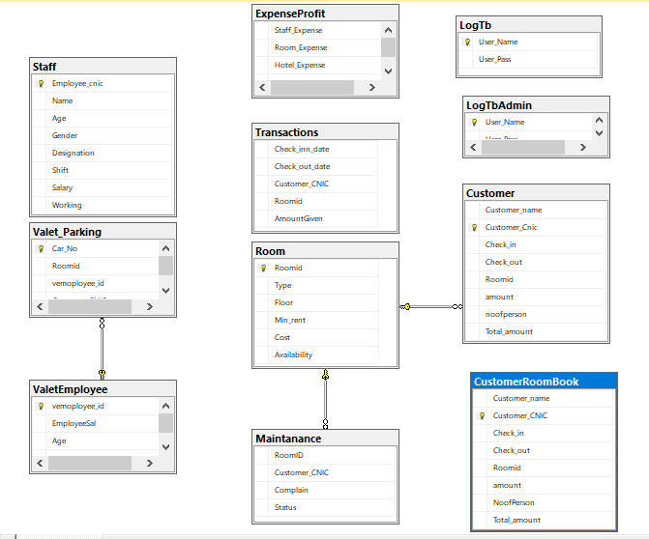

**SYSTEM IMPLEMENTATION**

***Introduction:***

We have created a database in **SQL Management Studio** and have connected it with **JAVA** in **Netbeans** version **8.2.** And all the queries of SQL queries are running in Netbeans through libraries.

java.sql.Connection;

java.sql.PreparedStatement;

java.sql.ResultSet;

java.sql.Statement;

***Queries:***

* select r.* from room r, CustomerRoomBook crb where r.Roomid =crb.Roomid and crb.check_out<='"+bookingdate1+"'
* select * from room where roomid='"+roomid+"'
* select * from customer where customer_cnic='"+cnic+"'"
* select * from room where Roomid not in (select Roomid from CustomerRoomBook where check_out>='2022-02-28')
* insert into CustomerRoomBook(Customer_name,Customer_CNIC,Check_In,CHeck_Out,Roomid,amount,NoofPerson,Total_amount)values('"+cname+"','"+cnic+"','"+checkin+"','"+checkout+"','"+roomid+"','"+amount+"','"+noofperson+"','"+total+"')
* delete from customer where Customer_cnic='"+cnic+"'
* select * from CustomerRoomBook where Customer_Cnic='"+nic+"'and check_in='"+checkinn+"'
* insert into Customer(Customer_name,Customer_CNIC,Check_In,CHeck_Out,Roomid,amount,NoofPerson,Total_amount)values('"+cname+"','"+cnic+"','"+checkin+"','"+checkout+"','"+roomid+"','"+amount+"','"+noofperson+"','"+total+"')
* select * from CustomerRoomBook where check_out='"+bookingdate1+"'
* select * from staff where Employee_cnic='"+searchcnic+"'
* delete from staff where Employee_cnic='"+cnic+"'
* insert into Staff(Employee_cnic,Name,Age,Gender,Designation,Shift,Salary,working) + "values('"+cnic+"','"+Name+"','"+age+"','"+gender+"','"+desi+"','"+shift+"','"+salary+"','"+working+"')
* select cost from room where roomid='"+rid1+"'
* select * from customer where Check_out between '"+from+"' and '"+to+"'
* select * from Staff where designation='"+optione+"'
* delete from customer where Customer_cnic='"+cnic+"'
* select * from LogTb where User_Name='"+Uname+"' and User_Pass='"+Upass+"'
* insert into LogTb(User_Name,User_Pass)values('"+Uname+"','"+Upass+"')
* delete from LogTb where User_Name='"+name1+"'
* select * from LogTb where User_Name='"+sname+"'
* Update LogTb Set User_Name='"+newname+"' Where User_Name='"+oldname+"'
* select * from Staff where working = 'current'
* select * from Staff

**SCREEN SHOTS OF DATABASE & SYSTEM**

***Database Diagram:***



***System Screenshots:***

